WEEK 3 ASSESSMENT REPORT
Statistical Analysis and Predictive Modeling Using R

India Air Quality Analysis (2020–2025)

Submitted by | Priyadarsine G.N.
Programme | M.Sc. Data Science
Tool Used | R / RStudio
Statistical / Modeling Method | ANOVA and Linear Regression
Dataset | India Air Quality Dataset
Dataset Period | 1 January 2020 – 31 October 2025

Introduction
This Week 3 assessment focuses on statistical analysis and predictive modeling using R and RStudio. The India Air Quality dataset used in Weeks 1 and 2 was continued so that the statistical and predictive analysis could be performed on the same prepared dataset. The main objective was to investigate the distribution and relationships in AQI data, perform hypothesis testing, build a regression model, and evaluate its predictive performance.
The analysis includes descriptive statistics, Pearson correlation, a Shapiro-Wilk normality test, a one-way ANOVA to test whether average AQI differs across months, and a linear regression model to predict AQI.Value using Year and Month. The predictive model was evaluated using an 80/20 train-test split and 5-fold cross-validation. MAE, RMSE and R-squared were used as performance measures, followed by actual-versus-predicted and residual diagnostic plots.

Dataset Identification and Rationale
The selected dataset contains 378,328 air-quality observations from Indian cities. The available period runs from 1 January 2020 to 31 October 2025. The dataset contains Date, S.No, City, Air.Quality, AQI.Value and Prominent.Pollutant. AQI.Value was selected as the target variable for regression because it is numerical and suitable for continuous prediction.
The dataset is suitable for this assessment because it contains a large number of observations and provides time-related variables and city information that can be examined statistically. It also provides enough observations for a train-test split and cross-validation.

Data Preparation
The Date variable was converted from character format into an R Date object. Year was extracted as a numeric variable and Month was converted to a factor with the natural January-to-December ordering. City and Air.Quality were also converted to factors. Missing-value checks showed zero missing values in the variables used for the analysis.
aqi$Date <- as.Date( aqi$Date,
format = "%d-%m-%Y"
)

aqi$Year <- as.numeric( format(aqi$Date, "%Y")
)

aqi$Month <- factor( format(aqi$Date, "%B"), levels = month.name
)

aqi$City <- factor(aqi$City) aqi$Air.Quality <- factor(aqi$Air.Quality)

colSums(is.na(aqi))
Result: No missing values were found in the dataset variables checked.

Exploratory Statistical Analysis

Descriptive Statistics
Descriptive statistics were calculated for AQI.Value to understand its central tendency and spread.

Statistic | Value
Mean | 109.548
Median | 88.000
Standard Deviation | 74.007
Minimum | 3.000
Maximum | 500.000
The mean AQI is higher than the median, indicating a positively skewed distribution. The wide range from 3 to 500 also shows substantial variation in AQI values.

Correlation Analysis
year_aqi_correlation <- cor( aqi$Year,
aqi$AQI.Value, method = "pearson"
)

print(year_aqi_correlation)
The Pearson correlation between Year and AQI.Value was -0.1257. This indicates a weak negative linear relationship between year and AQI in the full dataset. Correlation alone does not imply causation.

Normality Test
set.seed(123)

aqi_sample <- sample( aqi$AQI.Value,
5000
)
shapiro_result <- shapiro.test(aqi_sample) print(shapiro_result)
The Shapiro-Wilk test produced W = 0.85957 with p < 2.2 × 10^-16. Therefore, the null hypothesis of normality is rejected for the sampled AQI values. This result is consistent with the earlier distribution analysis showing a non-normal, right-skewed AQI distribution.

Hypothesis Testing – One-Way ANOVA
The one-way ANOVA was used to test whether the mean AQI differs across the twelve months. Hypotheses:
    - H₀: The mean AQI is the same across all months.
    - H₁: At least one month has a different mean AQI.
anova_model <- aov( AQI.Value ~ Month, data = aqi
)

summary(anova_model)

The ANOVA produced an F-statistic of approximately 10,222 with p < 2 × 10^-16. Since the p-value is far below the 0.05 significance level, H₀ is rejected. The analysis therefore provides strong statistical evidence that average AQI differs across months.
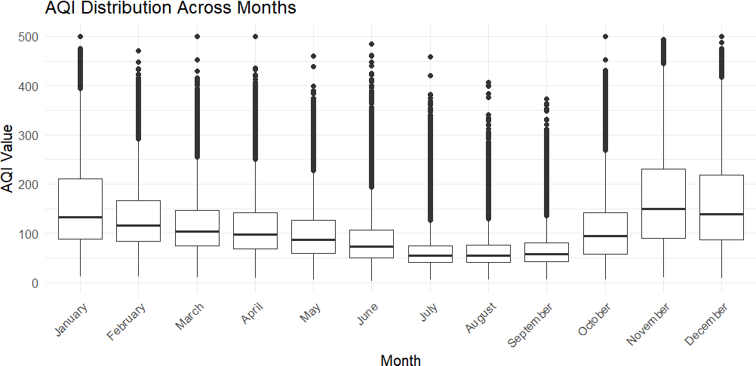

Figure 1: AQI Distribution Across Months

Predictive Model Development
A linear regression model was developed to predict AQI.Value. Year and Month were selected as predictors because the statistical analysis showed a relationship between AQI and time-related variation. Air.Quality was not used as a predictor because it is an AQI category derived from AQI and would introduce data leakage into the prediction task.
The dataset was divided into 80% training data and 20% testing data. The training set contained 302,662 observations and the test set contained 75,666 observations.
set.seed(123)

train_index <- sample( 1:nrow(model_data),
size = 0.80 * nrow(model_data)
)

train_data <- model_data[train_index,] test_data <- model_data[-train_index,]

lm_model <- lm(
AQI.Value ~ Year + Month, data = train_data
)

summary(lm_model)

Regression Model Results
The fitted regression model was statistically significant overall, with an F-statistic of 7830 and p < 2.2 × 10^-
16. The model's Multiple R-squared was 0.2369, indicating that Year and Month explain approximately 23.7% of the variation in AQI in the training data.
Most month coefficients were statistically significant relative to the January reference month. The December coefficient was not statistically significant at the 0.05 level (p = 0.158), while the other reported month effects were statistically significant.

Test-Set Model Performance
Metric | Result
MAE | 47.426
RMSE | 64.395
R-squared | 0.239
The Mean Absolute Error of 47.426 means that, on average, the absolute difference between the actual and predicted AQI values was about 47.4 AQI points on the test data. The RMSE was 64.395, which is higher than MAE because RMSE gives greater weight to larger prediction errors. The test R-squared of 0.239 indicates that the model explains approximately 23.9% of the variation in the unseen test data.

Five-Fold Cross-Validation
Five-fold cross-validation was performed on the training data to examine the stability of model performance. The training data was divided into five folds, with each fold used once as validation data while the other four folds were used for training.

Fold | MAE | RMSE | R²
1 | 47.573 | 64.494 | 0.238
2 | 47.729 | 64.620 | 0.234
3 | 47.566 | 64.496 | 0.240
4 | 47.805 | 64.789 | 0.234
5 | 47.803 | 65.054 | 0.239
Average | 47.695 | 64.690 | 0.237
The cross-validation results are close across all five folds. The average CV MAE was 47.695, average CV RMSE was 64.690, and average CV R² was 0.237. The similarity between cross-validation and test-set performance indicates that the baseline model has reasonably stable performance, although its predictive power is limited.

Diagnostic Analysis
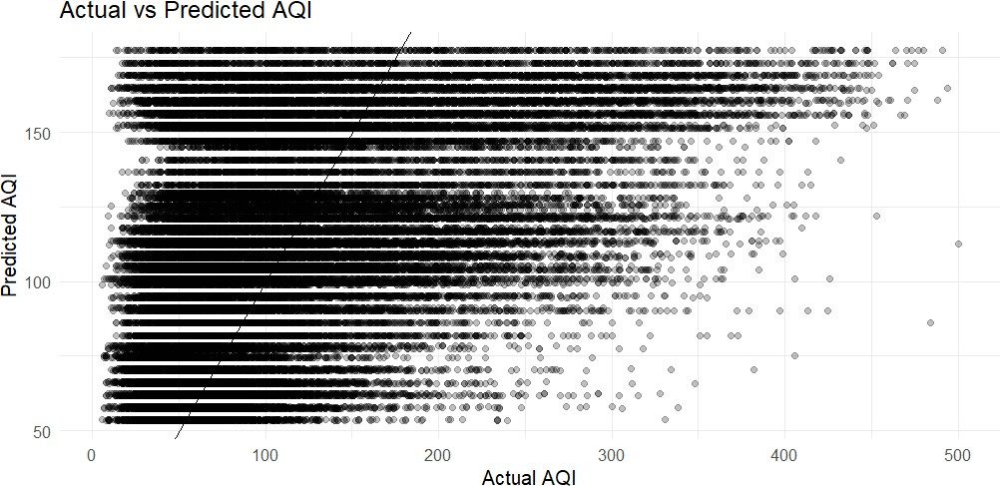

Figure 2: Actual vs Predicted AQI

The actual-versus-predicted plot shows considerable scatter around the reference line. The model captures some broad AQI patterns but does not closely predict many observations, especially higher AQI values. This is consistent with the relatively low R².
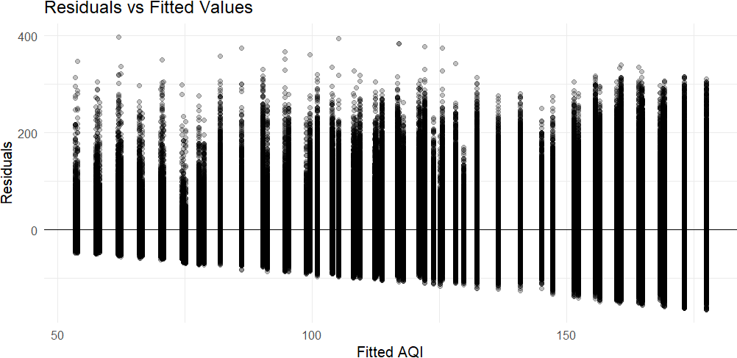

Figure 3: Residuals vs Fitted Values

The residual plot shows a structured pattern and changing spread rather than a completely random cloud around zero. This indicates that the simple Year + Month model does not capture all important factors associated with AQI and that the linear-model assumptions are not fully satisfied.

Model Strengths and Potential Improvements
Strengths:
- The model is simple and interpretable.
- The model uses a clear 80/20 train-test split.
- Five-fold cross-validation was used to check performance stability.
- Performance was evaluated using multiple metrics rather than a single score.
- Diagnostic plots were used to identify limitations instead of relying only on numerical metrics.
Potential improvements:
- Include additional explanatory variables such as city-level information and separate pollutant measurements when available.
- Consider nonlinear models because AQI relationships may not be purely linear.
- Evaluate tree-based models such as Random Forest or Gradient Boosting for comparison.
- Use time-aware validation for forecasting-oriented applications rather than a purely random split.
- Investigate transformations or alternative regression methods to address the non-normal distribution and residual pattern.

Conclusion
This Week 3 assessment successfully combined statistical analysis and predictive modeling using R. The AQI data showed a mean of 109.55 and a median of 88, with substantial variability and a non-normal distribution. Pearson correlation indicated a weak negative relationship between Year and AQI. The one-way ANOVA found a statistically significant difference in average AQI across months. A baseline linear regression model using Year and Month was then developed and evaluated using an 80/20 split and five-fold cross-validation. The model achieved a test MAE of 47.426, RMSE of 64.395 and R² of 0.239. The results indicate that the model provides a useful baseline but has limited predictive power because important factors influencing AQI are not included. The diagnostic plots support this conclusion and provide clear directions for future improvement.

R Code Appendix
# Load data and packages library(ggplot2)

file_path <- "C:/Users/PRIYA/OneDrive/Desktop/YuvaIntern_AQI_Analysis/AQI_2020_to_2025_October.csv" aqi <- read.csv(file_path, stringsAsFactors = FALSE)

# Prepare variables
aqi$Date <- as.Date(aqi$Date, format = "%d-%m-%Y") aqi$Year <- as.numeric(format(aqi$Date, "%Y"))
aqi$Month <- factor(format(aqi$Date, "%B"), levels = month.name) aqi$City <- factor(aqi$City)
aqi$Air.Quality <- factor(aqi$Air.Quality)

# Descriptive statistics colSums(is.na(aqi))

aqi_statistics <- c(
Mean = mean(aqi$AQI.Value), Median = median(aqi$AQI.Value), SD = sd(aqi$AQI.Value),

Minimum = min(aqi$AQI.Value), Maximum = max(aqi$AQI.Value)
)

# Correlation
cor(aqi$Year, aqi$AQI.Value, method = "pearson")

# Normality test set.seed(123)
aqi_sample <- sample(aqi$AQI.Value, 5000) shapiro.test(aqi_sample)

# Hypothesis testing
anova_model <- aov(AQI.Value ~ Month, data = aqi) summary(anova_model)

# Modeling data
model_data <- aqi[, c("AQI.Value", "Year", "Month")] model_data <- na.omit(model_data)
model_data$Month <- factor(model_data$Month, levels = month.name)

# 80/20 train-test split set.seed(123) train_index <- sample(
1:nrow(model_data),
size = 0.80 * nrow(model_data)
)
train_data <- model_data[train_index,] test_data <- model_data[-train_index,]

# Linear regression lm_model <- lm(
AQI.Value ~ Year + Month, data = train_data
)
summary(lm_model)

# Test predictions
test_predictions <- predict(lm_model, newdata = test_data)

actual <- test_data$AQI.Value predicted <- test_predictions

MAE <- mean(abs(actual - predicted))
RMSE <- sqrt(mean((actual - predicted)^2)) R_squared <- 1 -
sum((actual - predicted)^2) / sum((actual - mean(actual))^2)

print(MAE) print(RMSE) print(R_squared)

# 5-fold cross-validation set.seed(123)
k <- 5
folds <- sample(rep(1:k, length.out = nrow(train_data)))

cv_results <- data.frame( Fold = integer(),
MAE = numeric(), RMSE = numeric(), R2 = numeric()

)

for (i in 1:k) {
validation_index <- which(folds == i) cv_train <- train_data[-validation_index,]
cv_validation <- train_data[validation_index,]

cv_model <- lm(
AQI.Value ~ Year + Month, data = cv_train
)

cv_prediction <- predict( cv_model,
newdata = cv_validation
)

cv_actual <- cv_validation$AQI.Value

fold_mae <- mean(abs(cv_actual - cv_prediction)) fold_rmse <- sqrt(mean((cv_actual - cv_prediction)^2)) fold_r2 <- 1 -
sum((cv_actual - cv_prediction)^2) / sum((cv_actual - mean(cv_actual))^2)

cv_results <- rbind( cv_results, data.frame(
Fold = i,
MAE = fold_mae, RMSE = fold_rmse, R2 = fold_r2
)
)
}

print(cv_results) print(mean(cv_results$MAE)) print(mean(cv_results$RMSE)) print(mean(cv_results$R2))

# Actual vs predicted prediction_data <- data.frame(
Actual = actual, Predicted = predicted
)

ggplot(prediction_data, aes(x = Actual, y = Predicted)) + geom_point(alpha = 0.25) +
geom_abline(slope = 1, intercept = 0) + labs(
title = "Actual vs Predicted AQI", x = "Actual AQI",
y = "Predicted AQI"
) +
theme_minimal()

# Residual diagnostics residual_data <- data.frame(
Fitted = fitted(lm_model), Residuals = residuals(lm_model)
)

ggplot(residual_data, aes(x = Fitted, y = Residuals)) + geom_point(alpha = 0.25) +
geom_hline(yintercept = 0) + labs(
title = "Residuals vs Fitted Values", x = "Fitted AQI",
y = "Residuals"
) +
theme_minimal()

